Spring boot with mysql

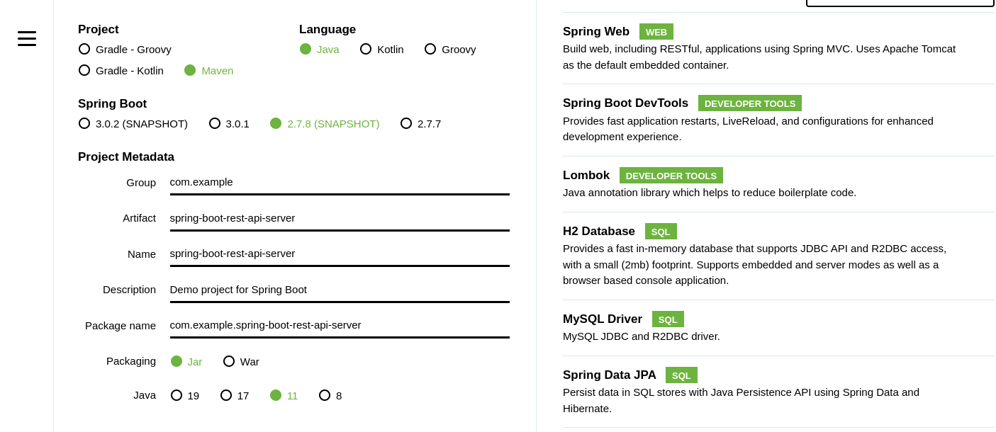

Create a product name

And add Spring web ,spring boot DevTools,lombok,h2database,mysql driver ,spring data jpa added dependencies

Pom.xml

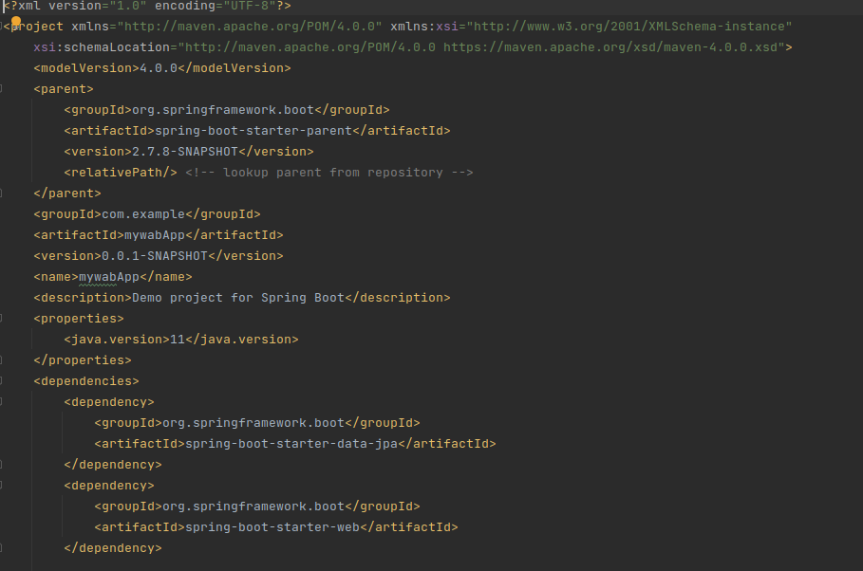

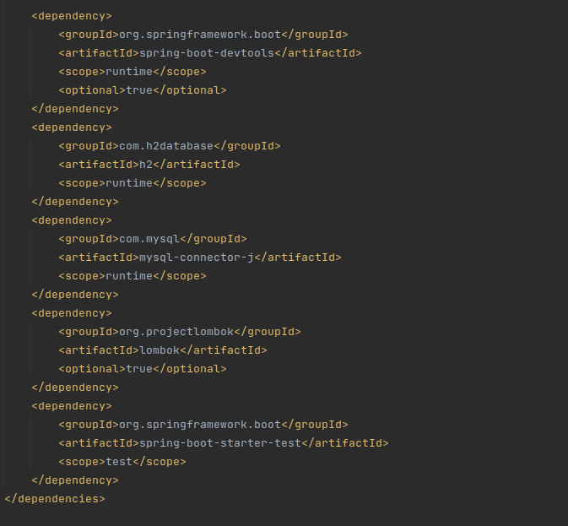

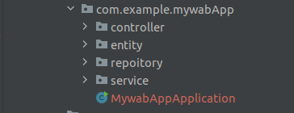

Use mydb;

Create table giit_employee;

Insert into giit_employee(id,employeeName,salary,status)values(1,”shiva”,322332,”working”);

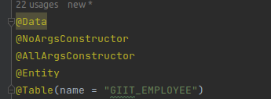

Used entity folder

I have used some variable and define Id annotation and use GeneratedValue annotation

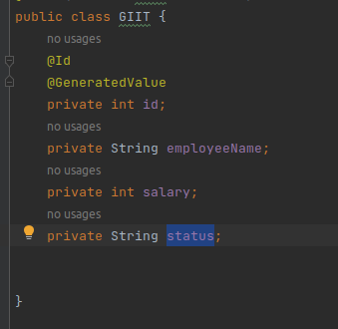

Used repository

There is create interface and extends JpaRepository and entity class name and take Integer based id and used findByEmployeeName method and take String type name pass it

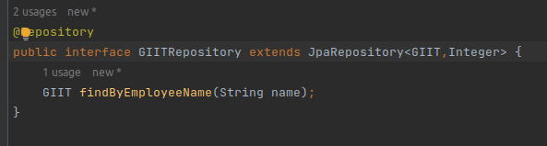

Used service

There is use business logic

We are using service file and define object type

After that create an argument type of GIIT file method name of saveGIIT and return and save it

Similarly saveGIITs method of argument and return and save all it

After that create another no argument method and return findAll

After that create a method pass argument type of integer id and return find by id and orelse not null

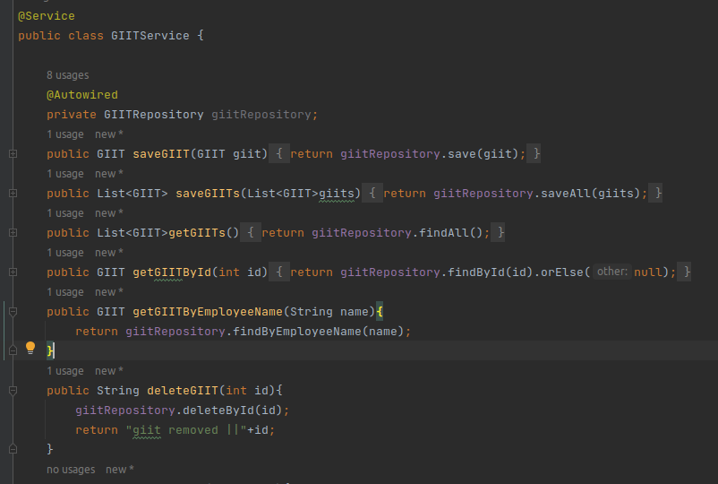

Used controller

Create an object type of GIITService

Define autowired annotation

There is using postmapping annotation and define variable and return it

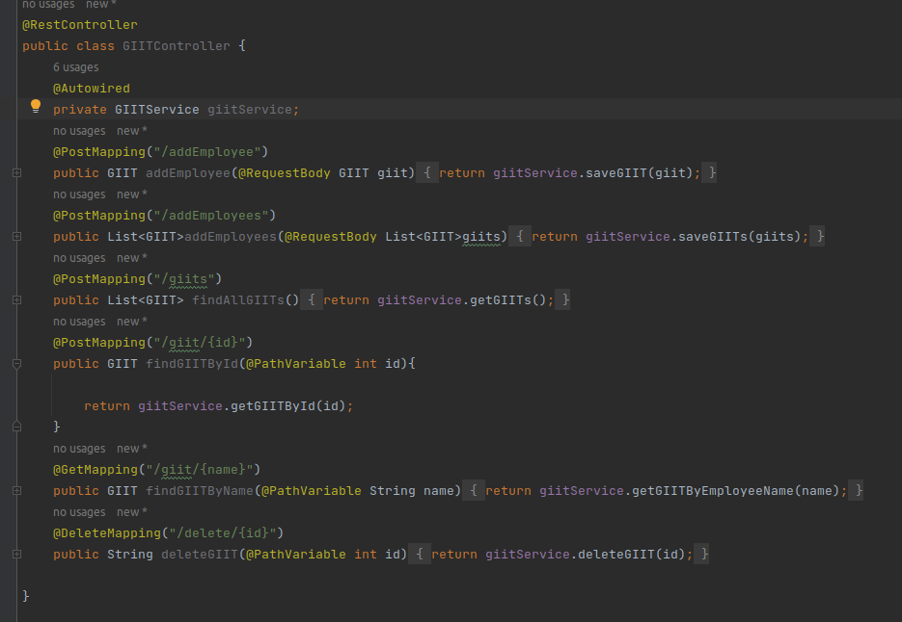

Application.properties

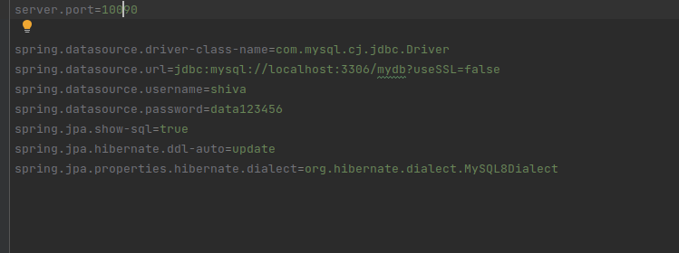

Postman run

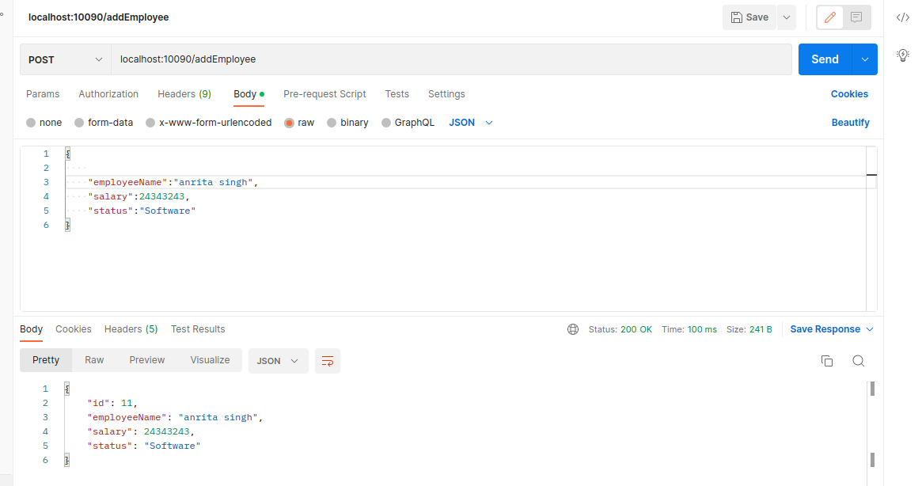

Post mapping

